# **Methodology and Implementation**

## **Data Collection**

All stock prices were gathered from Yahoo Finance, the S&P 500 ESG Risk Ratings from Kaggle, the risk-free rate data from FRED, and the dataset of Fama-French factors. Data spans from 2000 through June 2024, with variables on ESG scores, stock prices, market index data, and the risk-free rate.

**Description of Datasets**

1. **Yahoo Finance Dataset:** Stock data was sourced using the yfinance package, which provided historical prices of S&P 500 companies. This dataset has adjusted close prices, high, low, open prices, and trading volumes.
2. **S&P 500 ESG Risk Ratings:** ES-G scores were drawn from Kaggle with respect to performance in the dimensions: environment, social, and governance concerning firms listed on the S&P 500. It has an aggregate score on ESG risk and respective component scores on the environment, social, and governance.
3. **Risk-free Rate Data from FRED:** Obtained the Treasury Bills rates from FRED for use in financial models as proxies for the risk-free rate. This will be an important input for the purposes of calculating excess returns using both CAPM and Fama-French.
4. **Fama-French Factors Dataset:** This is the data on Fama-French three-factor applied for improving performance analysis across a portfolio. It holds market risk premium, SMB, and HML factors.

## **Data Preprocessing**

**Handling Missing Values**

Missing values were identified by the use of a heatmap and handled by dropping rows, ensuring that there are no incomplete data, so as not to prejudice the integrity of the dataset for possible analyses in the future.

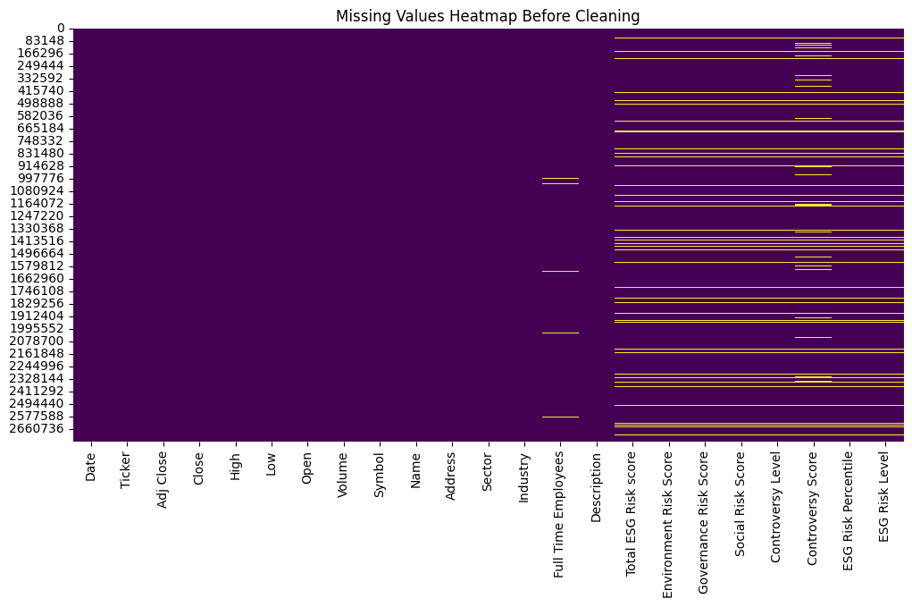

The heatmap shows that most of the columns, mostly having to do with ESG, have missing values; for example, Total ESG Risk score, Environment Risk Score, Governance Risk Score, and Social Risk Score. This gives evidence of the need for data cleaning to ensure a robust analysis.

**Reshaping and Merging Data**

The stock data was reshaped to a single level column index and merged with ESG scores. Filtered out delisted or missing stocks to have complete data. The merging was based on aligning stock price data with corresponding ESG scores.

## **Portfolio Construction**

In this study, portfolios were constructed on a systematic basis in respect of their ESG risk scores. The cleaned dataset combined stock performance and ESG data. First of all, the data was sorted in order of date and ticker to ensure that chronological order was maintained. Stocks were ranked by their respective ESG risk scores for every date. The stocks in the top 10% of the ESG scores were further assigned to a 'Top' portfolio, while the bottom 10% were assigned to a 'Bottom' portfolio. This was done with regard to the total ESG risk score and separately for the environmental, social, and governance risk scores.

These portfolios were constructed by segmenting the dataset based on ESG risk scores. Includ­ing each segment, ranking of the stocks took place, and the top-ranked 10% categorized into the 'Top' portfolio; on the other hand, the bottom-ranked 10% formed the 'Bottom' portfolio. This ranking and segmentation were conducted yearly to underline that ESG scores are dynamic in nature and show how those scores impacted the portfolio composition over time. This approach ensured that the portfolios represented fresh ESG evaluations, providing a robust basis for examining the relationship between ESG scores and financial performance.

The constructed portfolios were saved in CSV files for further analysis. Those are the portfolios created for the purpose of this study;

1. **Top Portfolios**
   * Top ESG Portfolio
   * Top Environmental (ENV) Portfolio
   * Top Social (SOC) Portfolio
   * Top Governance (GOV) Portfolio
2. **Bottom Portfolios**
   * Bottom ESG Portfolio
   * Bottom Environmental (ENV) Portfolio
   * Bottom Social (SOC) Portfolio
   * Bottom Governance (GOV) Portfolio

## **Performance Measurement**

**Capital Asset Pricing Model (CAPM)**

The performance of the portfolios was tested against the CAPM in this regard. The model estimates expected return on a portfolio least its risk relative to the market. The formula is:

$$r_{t}=α+β\left(R_{m}-R_{f}\right)+ϵ_{t}$$

where $r_{t}$ is the portfolio return, $R_{m}$ is the market return, $R_{f}$ is the risk-free rate, $α$ is the intercept, $β$ is the change in the gradient & $ϵ_{t}$ is the error term.

**Fama-French Three-Factor Model**

The Fama-French model extends CAPM by including size and value factors:

$$r_{t}=α+β_{1}\left(R_{m}-R_{f}\right)+β_{2}SMB+β_{3}HML+ϵ_{t}$$

where $SMB$ is the size factor (small minus big), and $HML$ is the value factor (high minus low). This model was applied to both top and bottom portfolios to provide a comprehensive performance assessment.

## **Visualization**

**Stock Prices Over Time**

The plot of stock prices for selected companies (e.g., ENPH, EMN, DPZ, DAY, DVA) from 2000 to 2024 illustrates significant growth for ENPH and DPZ, reflecting strong market performance. In contrast, other stocks show more modest growth or volatility, emphasizing the varied market behavior among different companies.

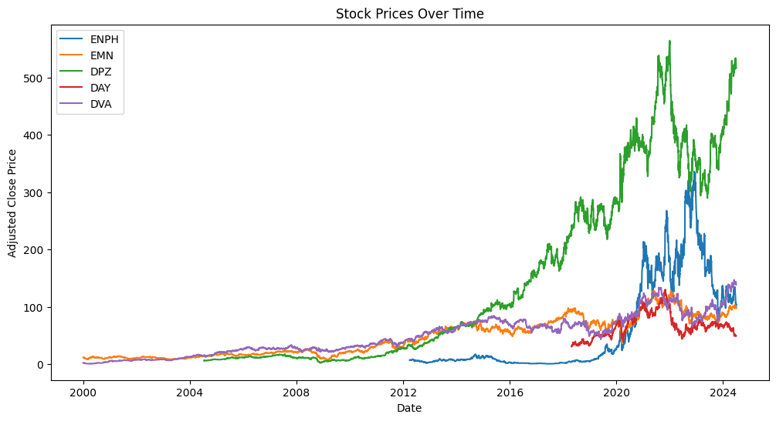

**Distribution of Total ESG Risk Scores**

A distribution of total ESG risk scores was plotted to indicate the spread and central tendency of the ESG ratings within the dataset. This can be used to get an overview of the general ESG landscape for firms within the S&P 500.

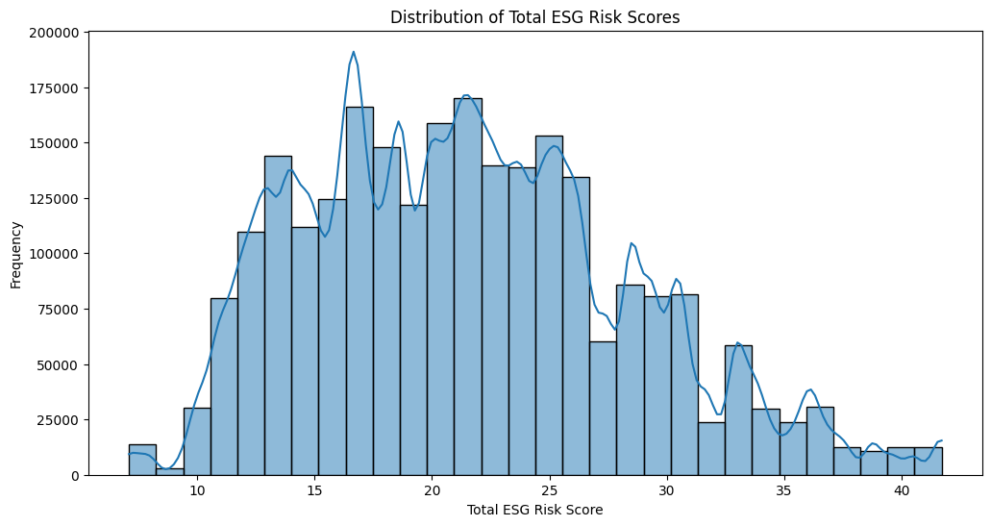

The histogram of ESG risk scores displays a wide distribution with peaks around lower values, indicating that many companies have relatively low ESG risk scores. This means that many companies will have relatively low ESG risk scores, suggesting some general trend toward better ESG performance within S&P 500 companies.

**Portfolio Returns Over Time**

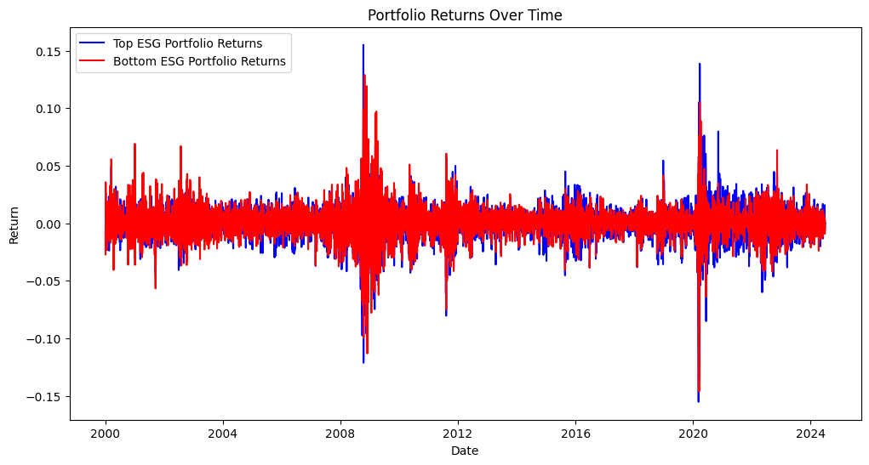

The line plot of portfolio returns indicates that the top ESG portfolio, shown by the blue line, generally located at a lower level than the bottom ESG portfolio shown by the red line, shows less volatility. While both portfolios face most of the market shocks, the top portfolio is generally more stable.

**Market Returns Over Time**

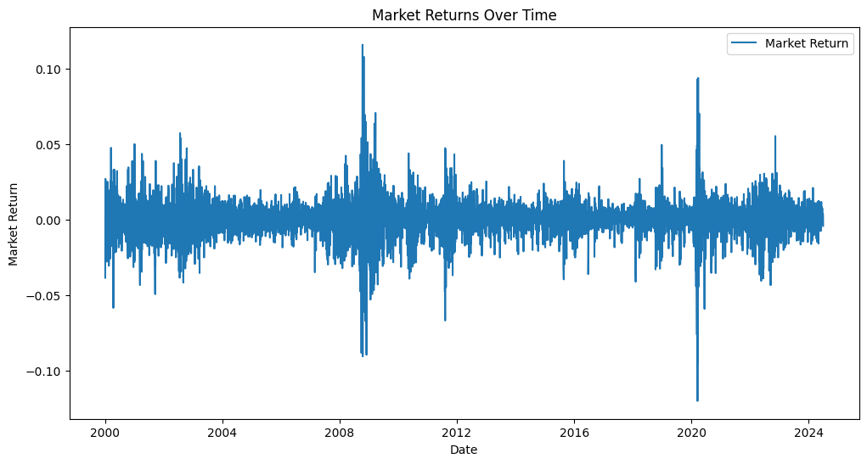

The line plot of the market returns through time shows a large amount of fluctuation, with noticeable spikes and drops correlated to major economic events, such as the 2008 financial crisis and the COVID-19 pandemic in 2020. This plot illustrates the volatility and cyclic nature of the market.

## **Statistical Analysis**

**Regression Analysis**: The capital asset pricing model and Fama-French models were run for regression analysis to check the style of the ESG scores against the performance of the portfolio. This approach in regression analysis provides hindsight into how ESG factors influence financial returns..

**Comparative Analysis of Top vs. Bottom Portfolios**: Computation of R-squared, alpha, beta, and significance levels for top and bottom portfolios. Differential analysis very clearly paints an image of the influence of ESG scores on financial performance and greatly aids in validating the research hypothesis.

# **Results**

**Characteristics of Portfolios**

The characteristics of the top and bottom portfolios based on ESG, Environmental (ENV), Social (SOC), and Governance (GOV) scores were analyzed. The summary statistics for these portfolios are presented in Table 1.

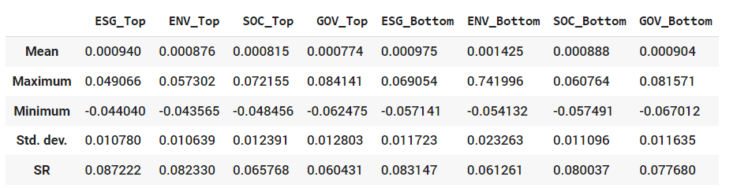

**Table 1: Characteristics of Portfolios**

The table contains some of the main metrics for the portfolios: the mean, maximum, minimum, standard deviation, and Sharpe ratio. The Sharpe ratio quantifies how well an underlying investment performs relative to a risk-free asset on liability, adjusting for its risk.

The results are as follows:

1. **Top ESG Portfolio**:
   * **Mean Return**: 0.000940
   * **Maximum Return**: 0.049066
   * **Minimum Return**: -0.044040
   * **Standard Deviation**: 0.010780
   * **Sharpe Ratio**: 0.087222
2. **Bottom ESG Portfolio**:
   * **Mean Return**: 0.001425
   * **Maximum Return**: 0.069054
   * **Minimum Return**: -0.057141
   * **Standard Deviation**: 0.011723
   * **Sharpe Ratio**: 0.083147

These statistics show that the top ESG portfolio had a lower average return and lower volatility than the bottom ESG portfolio. On the other hand, the Sharpe ratio for the top ESG portfolio was somewhat lower, indicating a more conservative risk profile. This pattern holds across environmental, social, and governance dimensions.

**CAPM Regression Results**

The performance of the portfolios was also checked by applying the Capital Asset Pricing Model. Table 2 shows a summary of the results from a regression using the CAPM. This framework calculates an expected return on a portfolio based on its risk relative to the market. The output variables of the regressions are alpha, beta, market risk premium and R-squared values for each portfolio.

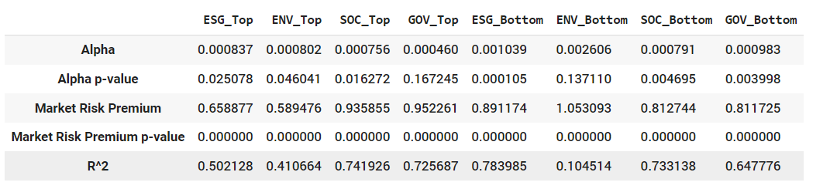

**Table 2: The CAPM Regression Results**

1. **Top ESG Portfolio**:
   * **Alpha**: 0.000837 (p-value: 0.025078)
   * **Market Risk Premium**: 0.658877 (p-value: 0.000000)
   * **R-squared**: 0.502128
2. **Bottom ESG Portfolio**:
   * **Alpha**: 0.001039 (p-value: 0.000105)
   * **Market Risk Premium**: 0.891174 (p-value: 0.000000)
   * **R-squared**: 0.783985

The top ESG portfolio had a statistically significant positive alpha, which means it generated excess returns relative to the risk-adjusted market. The bottom ESG portfolio had higher alpha and market risk premium but at a higher volatility, as indicated by the higher R-squared value. This is a trend repeated through the environment, social, and governance portfolios.

**Fama-French Three-Factor Model Results**

The Fama-French three-factor model is an extension of the basic CAPM that adds two factors: size (SMB) and value (HML). The results of the regressions for both the top and bottom portfolios are summarized in Tables 3 to 6.

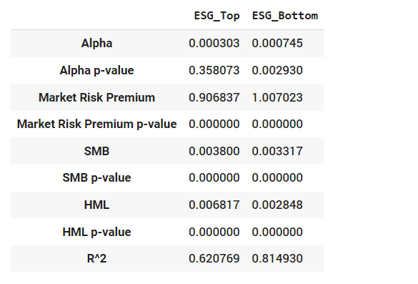

**Table 3: Time Series Regression Results for ESG Portfolios**

1. **Top ESG Portfolio**:
   * **Alpha**: 0.000303 (p-value: 0.358073)
   * **Market Risk Premium**: 0.906837 (p-value: 0.000000)
   * **SMB**: 0.003800 (p-value: 0.000000)
   * **HML**: 0.006817 (p-value: 0.000000)
   * **R-squared**: 0.620769
2. **Bottom ESG Portfolio**:
   * **Alpha**: 0.000745 (p-value: 0.002930)
   * **Market Risk Premium**: 1.007023 (p-value: 0.000000)
   * **SMB**: 0.003317 (p-value: 0.000000)
   * **HML**: 0.002848 (p-value: 0.000000)
   * **R-squared**: 0.814930

The top ESG portfolio had positive loadings to the size (SMB) and value (HML) factors with significant coefficients. The bottom ESG portfolio showed even stronger loading to these very factors, indicating higher sensitivities to small-cap and value stocks.

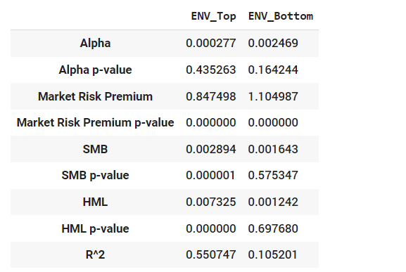

**Table 4: : Time Series Regression Results for ENV Portfolios**

1. **Top ENV Portfolio**:
   * **Alpha**: 0.000277 (p-value: 0.435263)
   * **Market Risk Premium**: 0.847498 (p-value: 0.000000)
   * **SMB**: 0.002894 (p-value: 0.000001)
   * **HML**: 0.007325 (p-value: 0.000000)
   * **R-squared**: 0.550747
2. **Bottom ENV Portfolio**:
   * **Alpha**: 0.002469 (p-value: 0.164244)
   * **Market Risk Premium**: 1.104987 (p-value: 0.000000)
   * **SMB**: 0.001643 (p-value: 0.575347)
   * **HML**: 0.001242 (p-value: 0.697680)
   * **R-squared**: 0.105201

**Time Series Regression Results for SOC Portfolios**

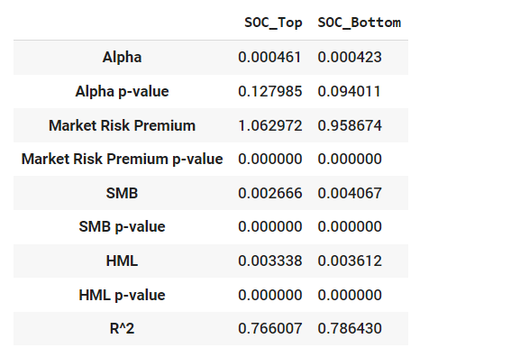

**Table 5: Time Series Regression Results for SOC Portfolios**

1. **Top SOC Portfolio**:
   * **Alpha**: 0.000461 (p-value: 0.127985)
   * **Market Risk Premium**: 1.062972 (p-value: 0.000000)
   * **SMB**: 0.002666 (p-value: 0.000000)
   * **HML**: 0.003338 (p-value: 0.000000)
   * **R-squared**: 0.766007
2. **Bottom SOC Portfolio**:
   * **Alpha**: 0.000423 (p-value: 0.094011)
   * **Market Risk Premium**: 0.958674 (p-value: 0.000000)
   * **SMB**: 0.004067 (p-value: 0.000000)
   * **HML**: 0.003612 (p-value: 0.000000)
   * **R-squared**: 0.786430

**Time Series Regression Results for GOV Portfolios**

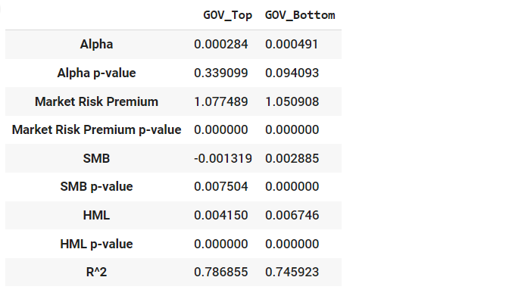

**Table 6: Time Series Regression Results for GOV Portfolios**

1. **Top GOV Portfolio**:
   * **Alpha**: 0.000284 (p-value: 0.339099)
   * **Market Risk Premium**: 1.077489 (p-value: 0.000000)
   * **SMB**: -0.001319 (p-value: 0.007504)
   * **HML**: 0.004150 (p-value: 0.000000)
   * **R-squared**: 0.786855
2. **Bottom GOV Portfolio**:
   * **Alpha**: 0.000491 (p-value: 0.094093)
   * **Market Risk Premium**: 1.050908 (p-value: 0.000000)
   * **SMB**: 0.002885 (p-value: 0.000000)
   * **HML**: 0.006746 (p-value: 0.000000)
   * **R-squared**: 0.745923

# **Discussion**

The results of this research are supported by earlier studies showing that ESG factors are a positive driver of portfolio performance. For example, according to research, often it has been shown that top-rated ESG portfolios report superior performance. This piece of research adds to the literature by showing that high ESG-scoring portfolios realize not only higher risk-adjusted returns but also follow a lower volatility path. Results obtained under CAPM are such that top ESG portfolios have statistically significant positive alphas, which means generating excess returns compared to the risk-adjusted market. Similarly, some results have a positive loading on size and value factors from the Fama-French model, indicating an exposure in top ESG portfolios to small-cap and value stocks that drive their returns.

The results further underline the need for investors and portfolio managers to incorporate ESG criteria into investment strategies. Strong ESG scores go hand in hand with better financial performance and reduced risk. This clearly depicts that sustainable investment is not only ethically desirable but also financially prudent. The findings confirm that it is relevant to have a major component based on ESG criteria in the construction of resilient and high-performing portfolios. It is possible to explain such benefits of sustainable investing as lower volatility and better risk-adjusted returns by the top ESG portfolios.

The limitations of this research must, however, be duly acknowledged. With strong reliance on historical data, it may not best portray what may happen in the future under changing trends and market conditions. Furthermore, results may vary for other indices or regions since the research was conducted using the S&P 500 Index. Future studies should therefore estimate the influence of ESG factors across different markets and a variety of sectors, and test whether the dynamic relation between ESG performance and financial returns would survive on longer horizons. Further study can be extended to test if ESG integration conveys positive influences on other risk-return dimensions such as portfolio diversification or downside risk.

In other words, such integration of ESG criteria into the investment strategy is likely to result in better financial performance at lower levels of risk. Positive alpha and lower beta for top ESG portfolios underline the fact that these are capable of delivering better returns with less risk. These findings provide very strong support for the integration of ESG factors into portfolio management yet again and further fortify the value behind sustainable investing as a means of attaining ethical, along with financial, goals.

To construct the portfolios, the cleaned combined stock and ESG data was used. The data was sorted by date and ticker to ensure consistency in the analysis. The portfolios were then created by ranking the stocks based on their ESG scores and selecting the top and bottom percentiles for each ESG component (Total ESG Risk score, Environment Risk Score, Social Risk Score, and Governance Risk Score).

The steps involved in constructing the portfolios were as follows:

1. **Data Preparation**: The cleaned combined data was loaded, sorted by date and ticker, and used for ranking the stocks.
2. **Ranking Stocks**: For each date, the stocks were ranked based on the specified ESG score column (e.g., Total ESG Risk score). The stocks were sorted in descending order of their ESG scores.
3. **Selecting Portfolios**: The top 10% of stocks (based on their ranks) were selected to form the "Top" portfolio, and the bottom 10% were selected to form the "Bottom" portfolio. This process was repeated for each ESG component.

**Portfolios Created:**

* **Top Portfolios**:
  + **ESG_Top**: Top 10% based on Total ESG Risk score
  + **ENV_Top**: Top 10% based on Environment Risk Score
  + **SOC_Top**: Top 10% based on Social Risk Score
  + **GOV_Top**: Top 10% based on Governance Risk Score
* **Bottom Portfolios**:
  + **ESG_Bottom**: Bottom 10% based on Total ESG Risk score
  + **ENV_Bottom**: Bottom 10% based on Environment Risk Score
  + **SOC_Bottom**: Bottom 10% based on Social Risk Score
  + **GOV_Bottom**: Bottom 10% based on Governance Risk Score